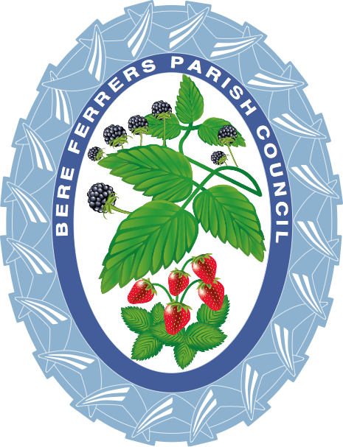
The Council Offices
Station Road
Bere Alston
Devon
PL20 7EJ

Tel: 01822 840748
bereferrersparishcouncil@btconnect.com
Chairman of Council:
Cllr. P. Crozier

Clerk to the Council:
Mrs. C. Metcalf

29th June 2022

Dear Sir / Madam,

You are hereby invited to a meeting of the Plans & Highways Committee, to be held in the Council Chambers on
Tuesday 5th July 2022 at 7 pm.

Yours faithfully
Caroline Metcalf
Caroline Metcalf
Parish Clerk to the Council

A G E N D A
- Apologies.
- Declarations of Interest Members are invited to declare any personal or disclosable pecuniary interest, including the nature and extent of such interests they may have in any items to be considered at this meeting. If Councillors have any questions relating to predetermination, bias or interests in items on this agenda, then please contact the Clerk in advance of the meeting.
- Notification of items for information at the discretion of the Chairman. No action can be taken on these items.
- Matters arising from minutes at the meeting held on the 31st May 2022.
- To deal with Planning Applications for comment. Interested parties are invited to comment on applications they have an interest in before a decision is made, at the discretion of the Chairman.
- Take note of any Planning Applications noted after consideration by the Borough.
- Enforcement cases to be taken in Part Two.
- The Co-Op Proposal.
- Road Warden Agreement.
- Update on cycle racks.
- Highways Updates/Issues.
- Correspondence.
- Questions from any members of public present at the meeting, at the discretion of the Chairman.
ANY MEMBERS OF THE PUBLIC ARE WELCOME TO ATTEND
1047/22/FUL Mr. & Mrs. P Callaway
Application for construction of a replacement 3–4-bedroom house at 49 Station Road, Bere Alston, PL20 7EN

1721/22/TCA Mr Martin Swarbrick, 39 Station Road Bere Alston Devon PL20 7AF
T1: Horse Chestnut - Fell and Remove due to tree overhanging neighbouring boundary to the South
and East, Tree also overhanging garden workshop, log store and chicken run. 1 x ascending main stem is dead/ dying with bark peeling off at 20 ft above ground level, tree is in poor health. Replant with nature broad leaf tree.

2017/22/TPO Mrs Suzie Johnstone, 33 Cornwall Street Bere Alston Devon PL20 7BE
T1: Spruce - section fell to ground level, this tree is now very large for the area it was planted (presumably a Christmas tree), it spans across two narrow gardens and as a result numerous other attractive shrubs are hindered. the tree is also shading and dropping needles in a small fish pond which will eventually increase the acidity levels of the water. The lack of light to the pond also decreases biodiversity amongst waterborne organisms.

